IMDB Movie Analysis

1. ****Movie Genre Analysis:**** Analyze the distribution of movie genres and their impact on the IMDB score.

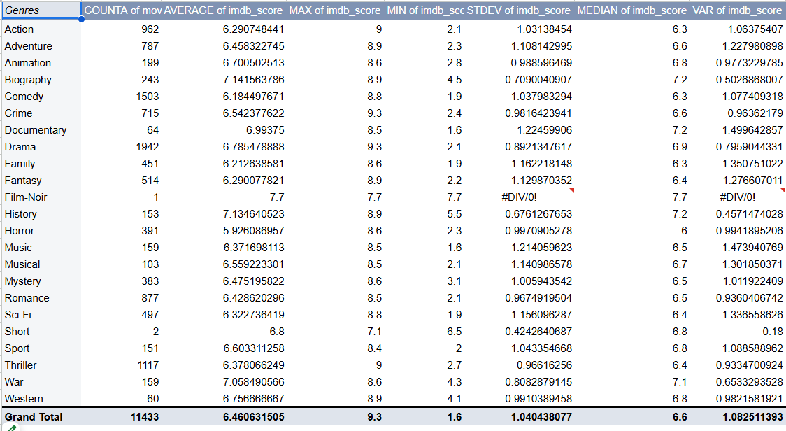

1. ****Movie Duration Analysis: Analyze the distribution of movie durations and its impact on the IMDB score****.

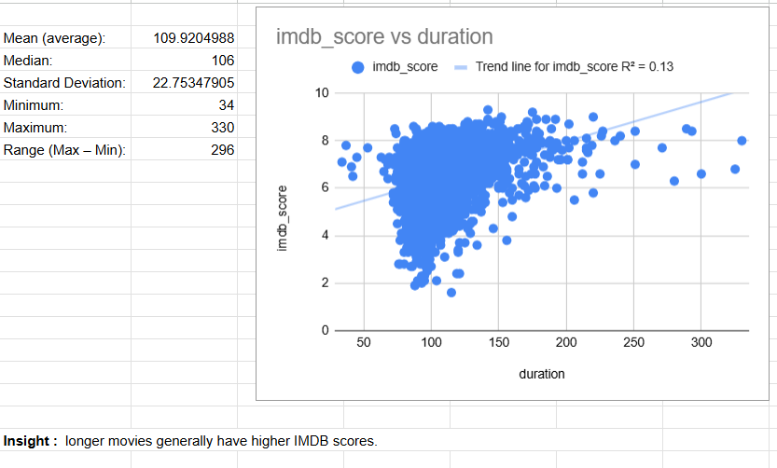

1. ****Language Analysis: Situation: Examine the distribution of movies based on their language.****

****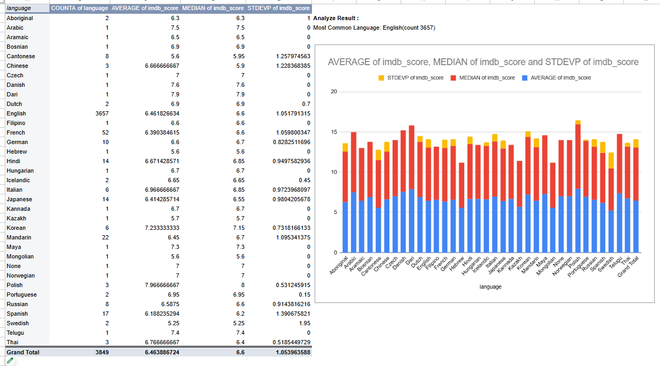****

1. ****Director Analysis: Influence of directors on movie ratings****.

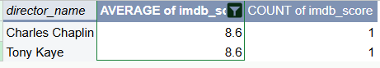

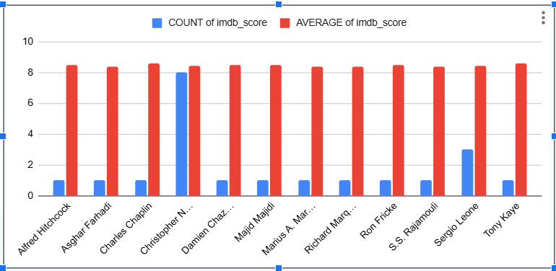

1. ****Budget Analysis: Explore the relationship between movie budgets and their financial success.****

****